Grove - Circular LED

|  |
| --- |
| **Contents**   [[hide](javascript:toggleToc())]   * [1 Introduction](http://www.seeedstudio.com/wiki/Grove_-_Circular_LED#Introduction) * [2 Features](http://www.seeedstudio.com/wiki/Grove_-_Circular_LED#Features) * [3 Schematic](http://www.seeedstudio.com/wiki/Grove_-_Circular_LED#Schematic) * [4 Specification](http://www.seeedstudio.com/wiki/Grove_-_Circular_LED#Specification) * [5 Interface](http://www.seeedstudio.com/wiki/Grove_-_Circular_LED#Interface) * [6 Usage](http://www.seeedstudio.com/wiki/Grove_-_Circular_LED#Usage)   + [6.1 Hardware](http://www.seeedstudio.com/wiki/Grove_-_Circular_LED#Hardware)   + [6.2 Software](http://www.seeedstudio.com/wiki/Grove_-_Circular_LED#Software) * [7 Source](http://www.seeedstudio.com/wiki/Grove_-_Circular_LED#Source) |

Introduction

This is a unique ring– it has a florid body with 24 controllable LEDs. Maybe it will drive the inspiration out of you to make a glowing magic ring! There is a 1*1 square hollow-out in the middle of this module, where you can place a Grove Encoder in and make it a rotary visual encoder!

[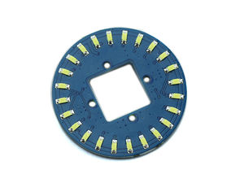](http://www.seeedstudio.com/wiki/File:Circular_LED.jpg) [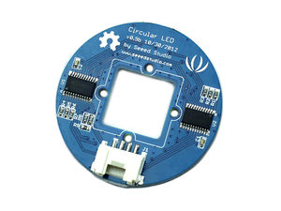](http://www.seeedstudio.com/wiki/File:Circular_LED_back.jpg)

Features

* Circular shape
* 24 LEDs, about 5.5 mA drive current for each channel.
* Controllable LEDs with florid effects
* Grove Interface.

Schematic

[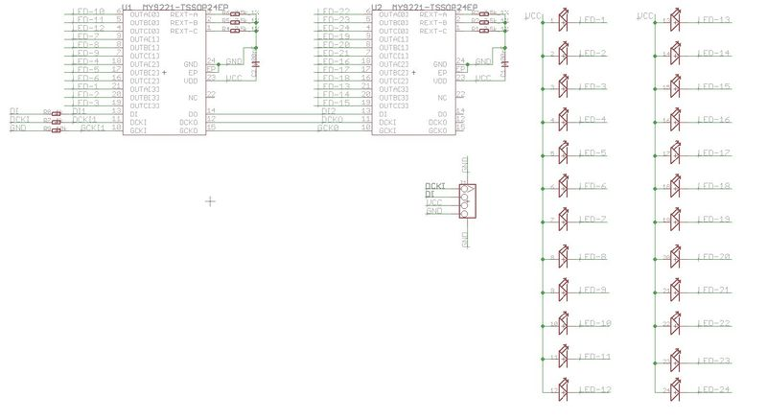](http://www.seeedstudio.com/wiki/File:Circular_LED_schmatic.jpg)

Specification

|  |  |  |  |  |
| --- | --- | --- | --- | --- |
| **Item** | **Min** | **Typical** | **Max** | **Unit** |
| **Voltage** | 4.5 | 5 | 5.5 | VDC |
| **Current** | / | 5.5 for each LED |  | mA |
| **Dimension** | Ring Form:4.5 diameter | | | mm |
| **Net Weight** | 12 | | | g |

Interface

[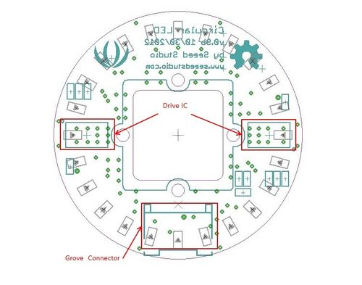](http://www.seeedstudio.com/wiki/File:Circular_LED_Interface.jpg)

Usage

**Hardware**

Connect this module to the I2C Connector of [Grove base shield](http://www.seeedstudio.com/wiki/Grove-Base_Shield_V1.3) with the 4- pin Grove cable. You can also connect the "DI" signal to A4 and "DCLK" to A5 with jumper wires.

**Software**

Please download the CircularLED lib and test this module with*CircularLEDtest* example. You can refer to [here](http://www.seeedstudio.com/wiki/Upload_Code) learn how to upgrade the sketches.  
[](http://www.seeedstudio.com/wiki/File:Circular_LED_shining.gif)  
Please also refer to the [Grove-Encoder](http://www.seeedstudio.com/wiki/Grove_-_Encoder) to learn more about this module.

Source

[CircularLED Library](http://www.seeedstudio.com/wiki/File:CircularLED.zip)  
[Grove-circular LED eagle files](http://www.seeedstudio.com/wiki/File:Grove-circular_LED_eagle_files.zip)